

**UNIVERSITY OF PETROLEUM & ENERGY STUDIES**

**Dehradun**

**CONTINOUS INTEGRATION**

**AND**

**CONTINOUS DELIVERY**

**Experiment**

**Name: Rakshit Kapoor**

**Course: B. TECH CSE DevOps (2018-22)**

**Roll no.: R171218082**

**Sapid: 500067642**

**Experiment-9**

**Uploading artifacts on Nexus server using command line**

**Step-1:** to download nexus server go to <https://www.sonatype.com/nexus/repository-oss/download>

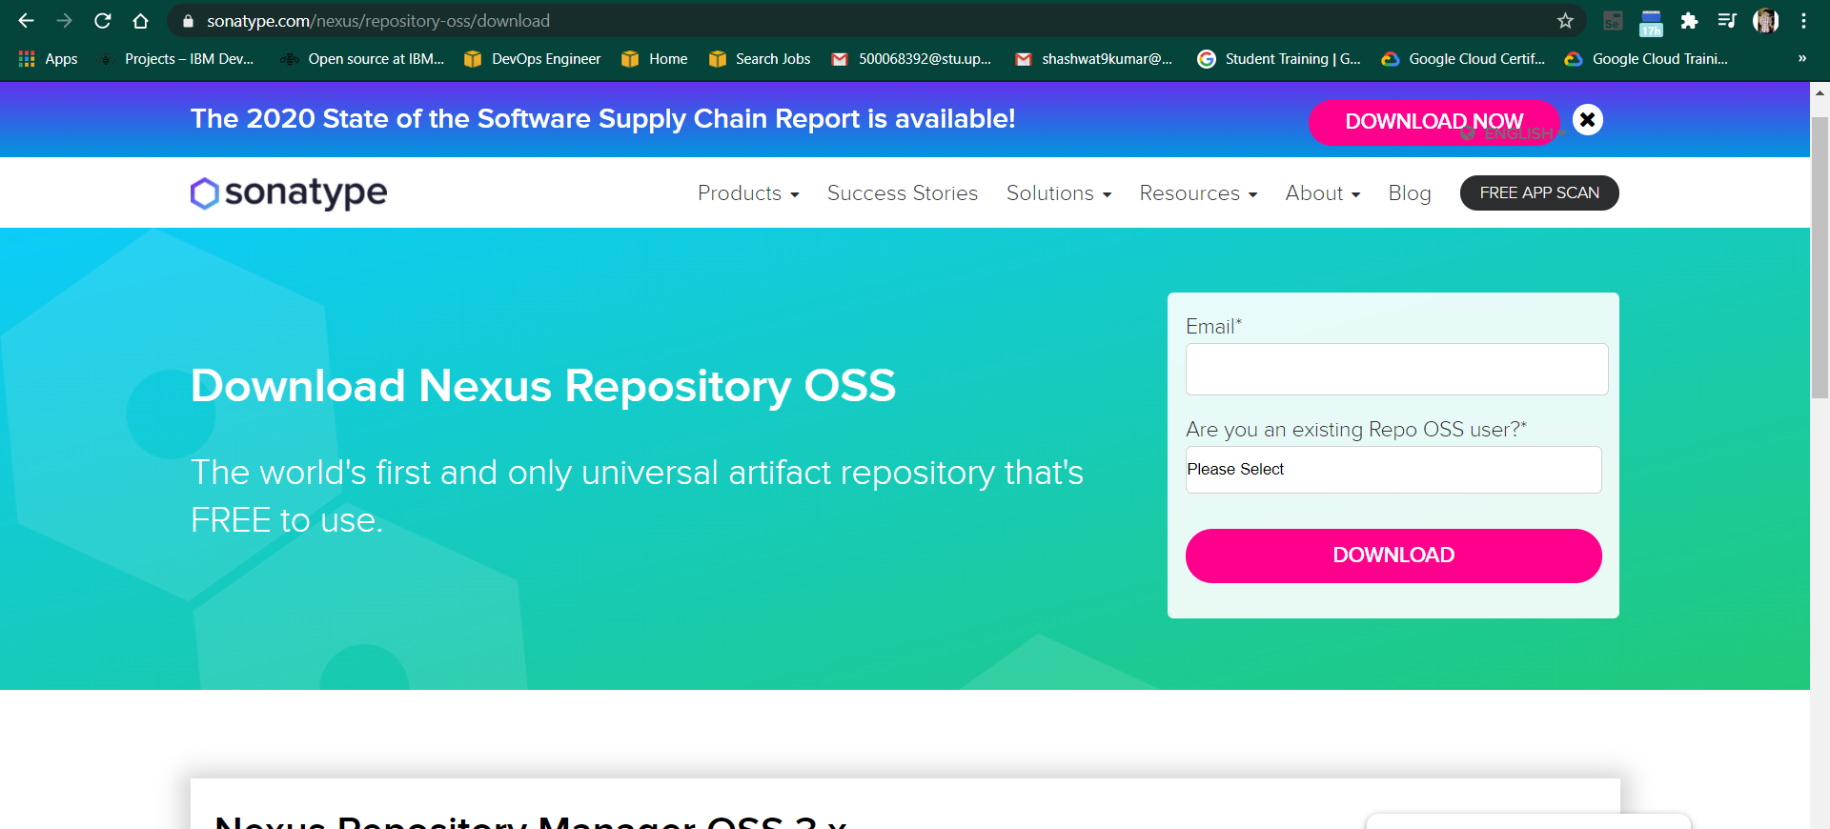

**Step-2:** Go to the location where nexus is installed. Open the bin folder to find nexus.exe file. Open command prompt in the same folder and run the following command : Nexus.exe /run

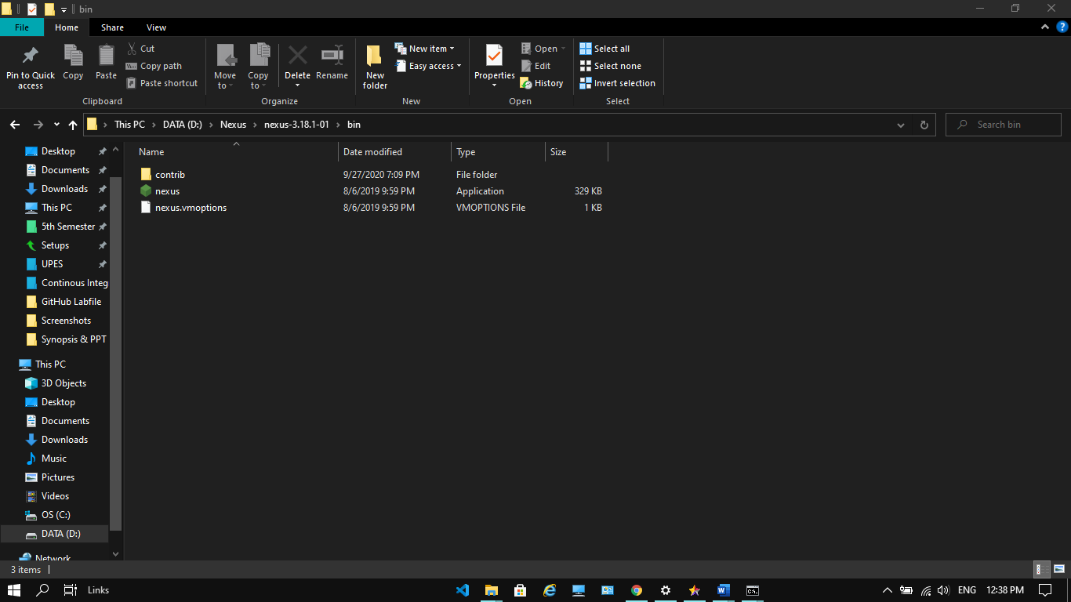

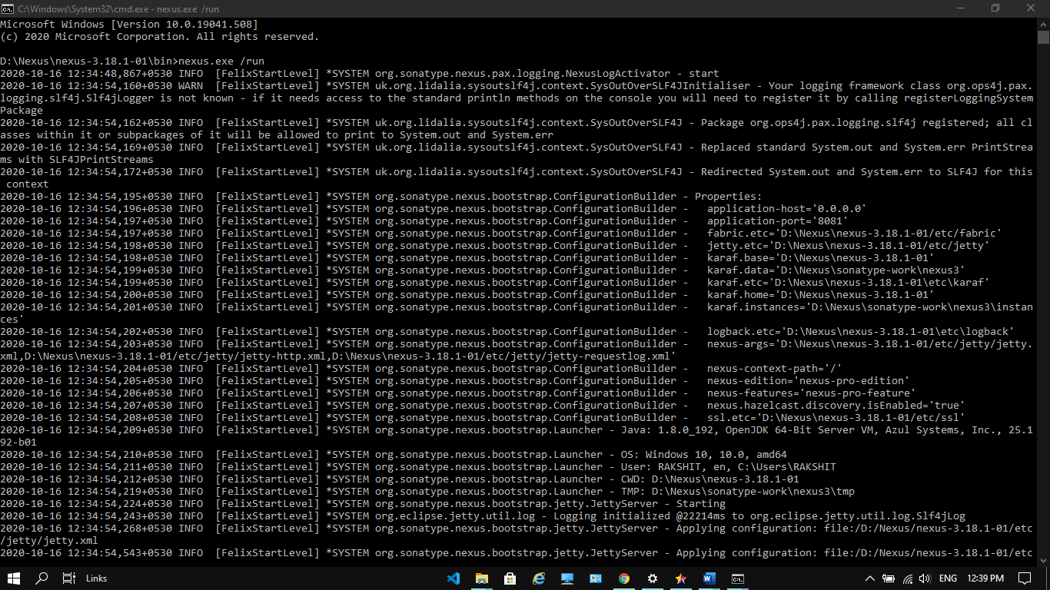

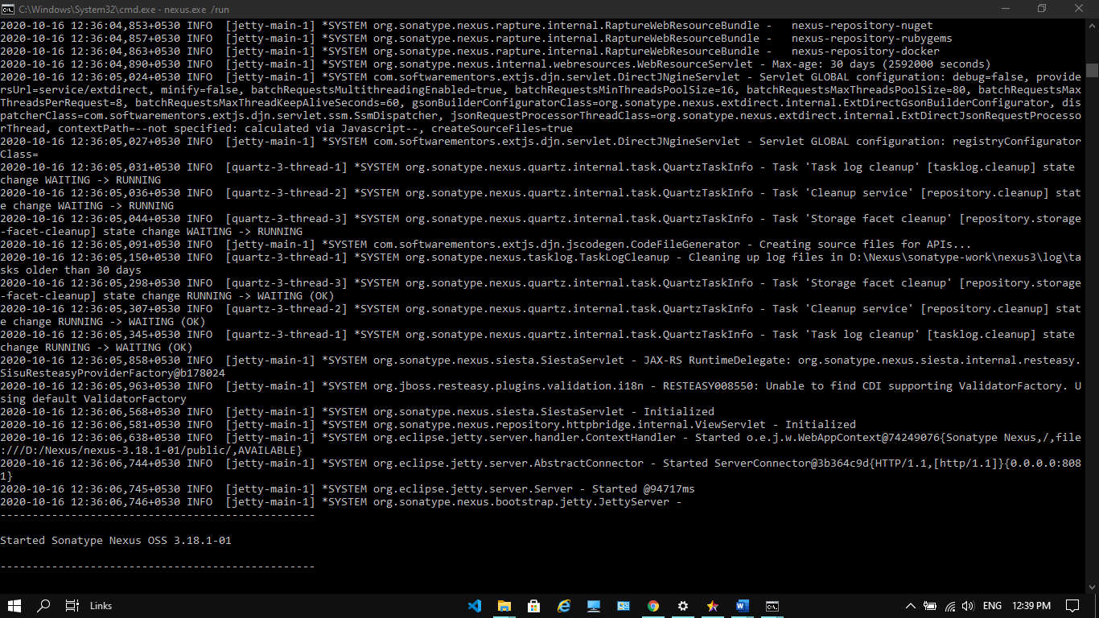

**Step-3:** Once the command runs head to localhost:8081, the port where Nexus server runs

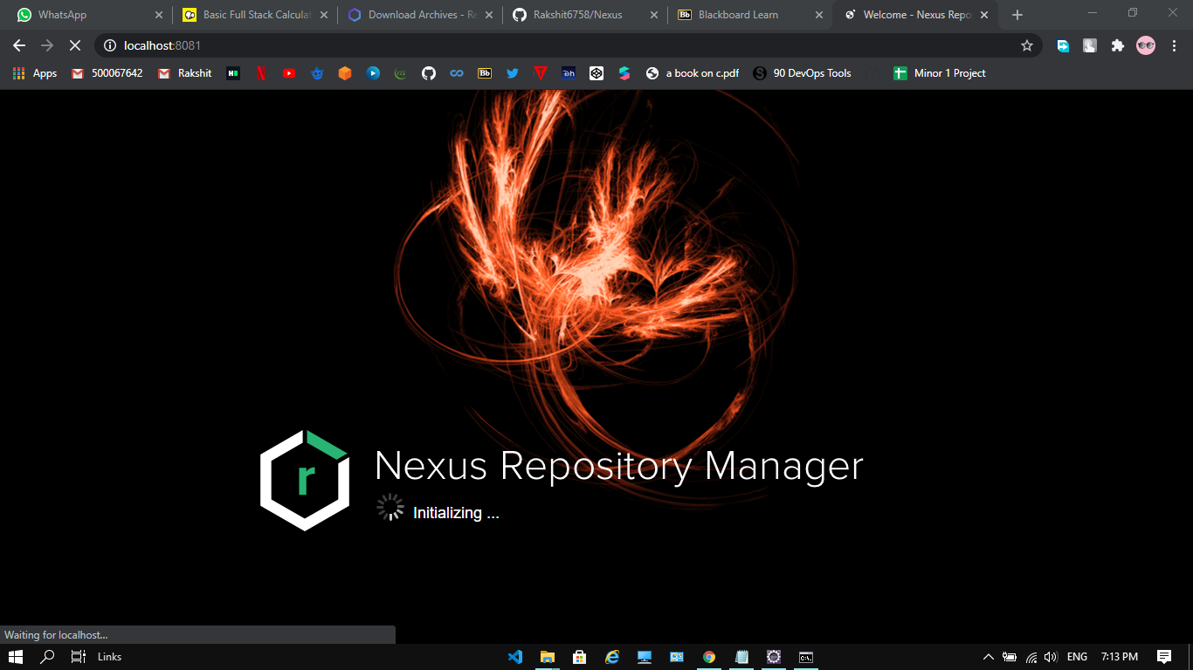

**Step-4:** Complete the set-up, to create a new admin username and password and login

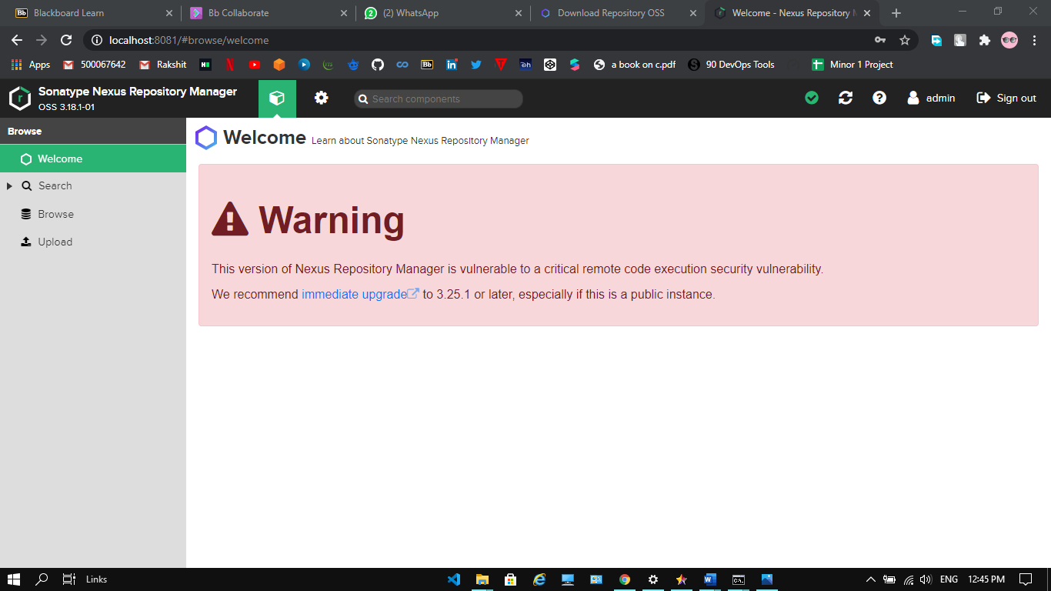

**Step-5:** Create a new repository in Nexus (here called “CICD-LAB7”) and copy its URL

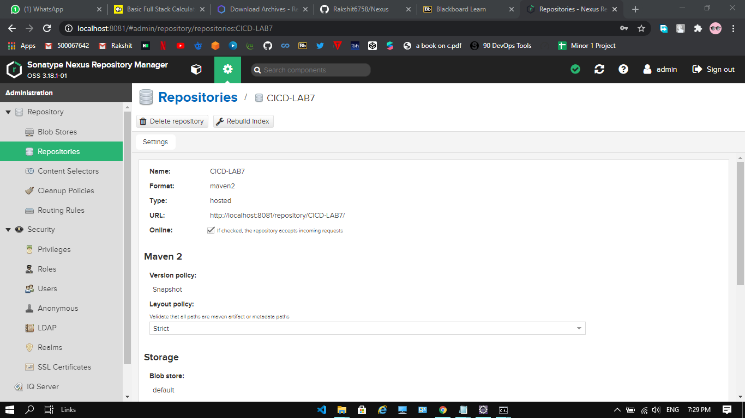

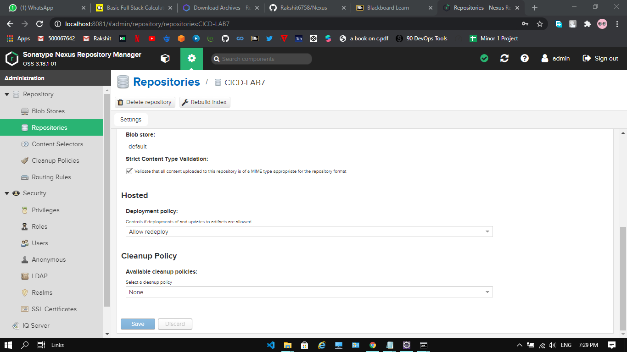

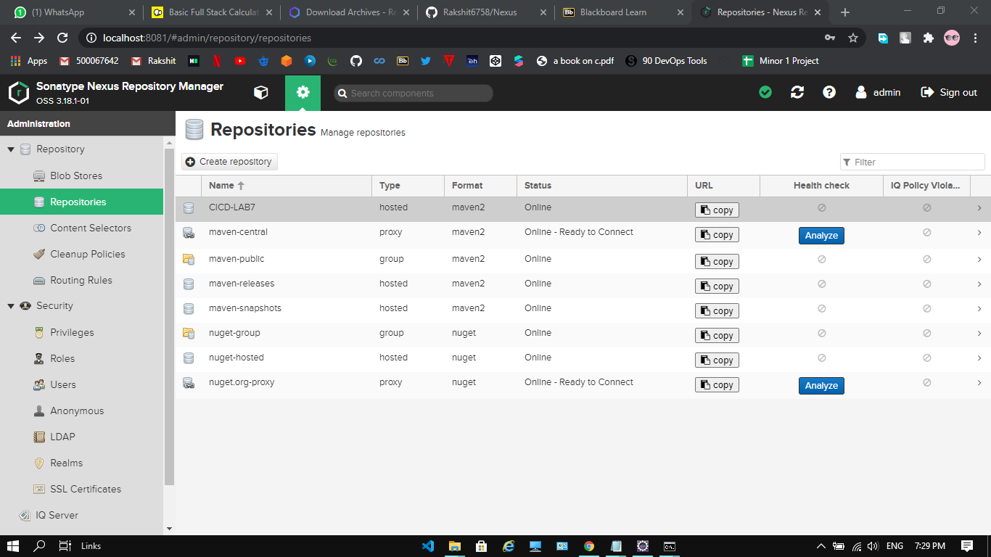

**Step-6:** Open the pom.xml of the Maven project to be published to Nexus. Add the snapshotRepository tag into the pom.xml and give the URL of Nexus repository copied.

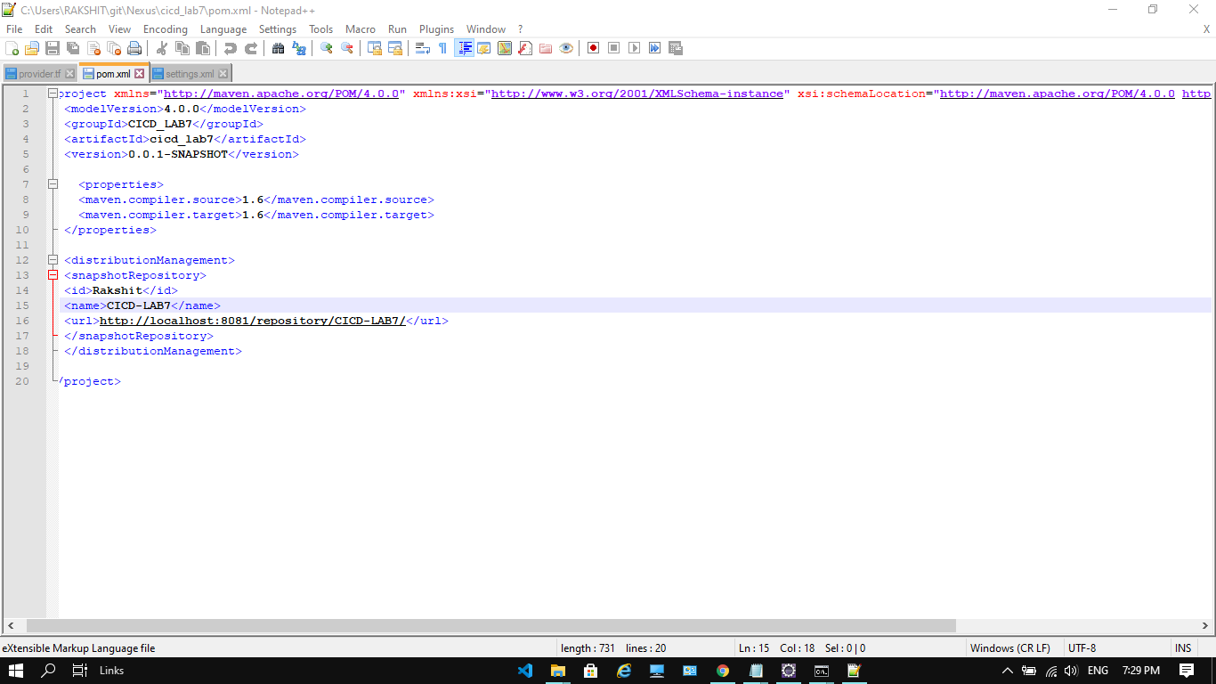

**Step-7:** Now, open setting.xml in the “apache-maven-3.6.3” folder. Add the tag of server with the required credentials.

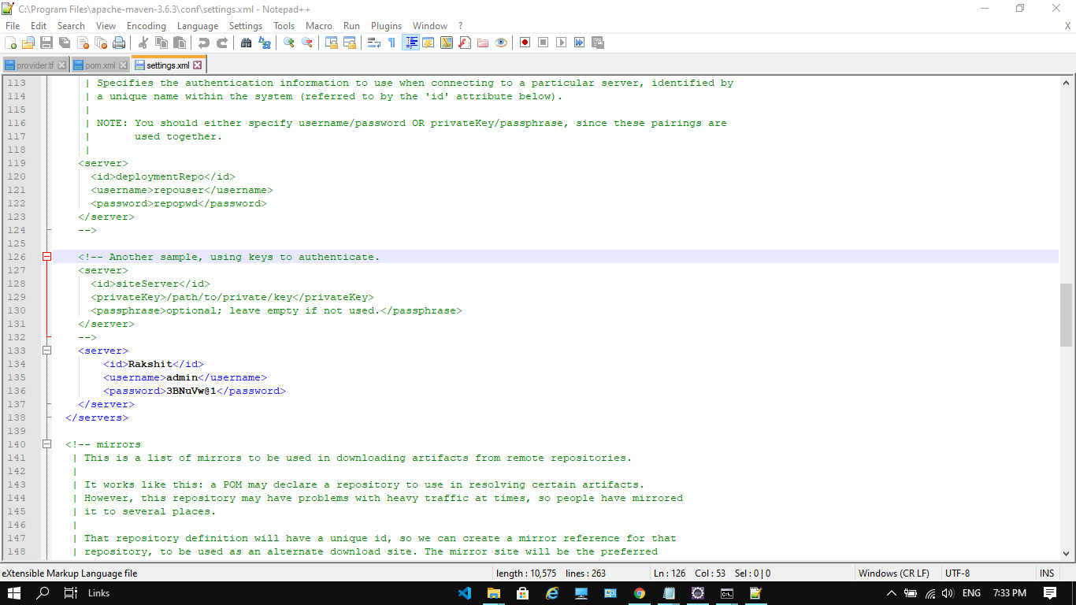

**Step-8:** To check the working of the maven project, open it in the command prompt and run “mvn clean”, “mvn install”, etc. command on it

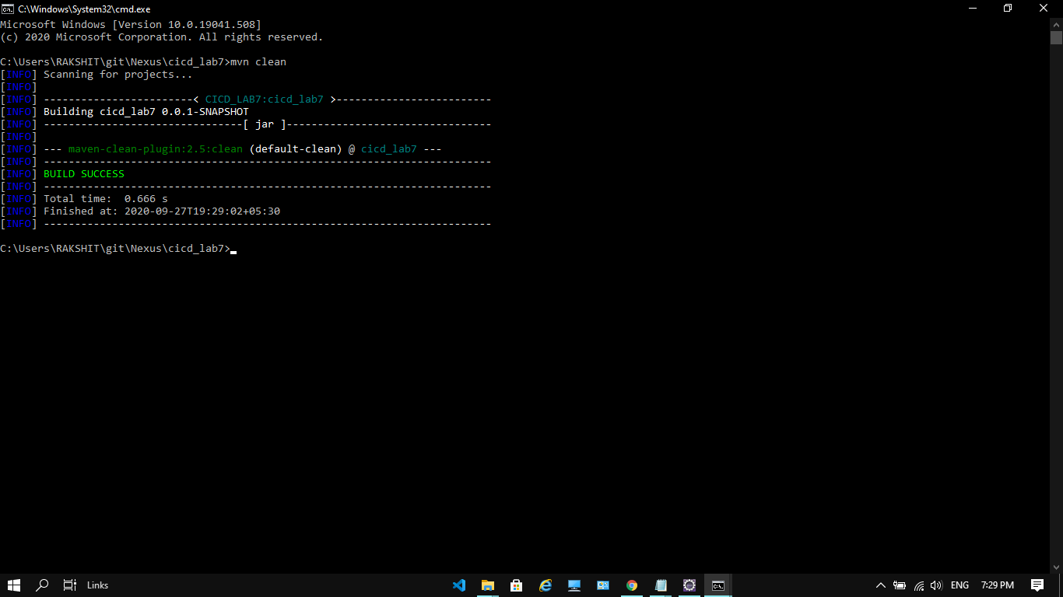

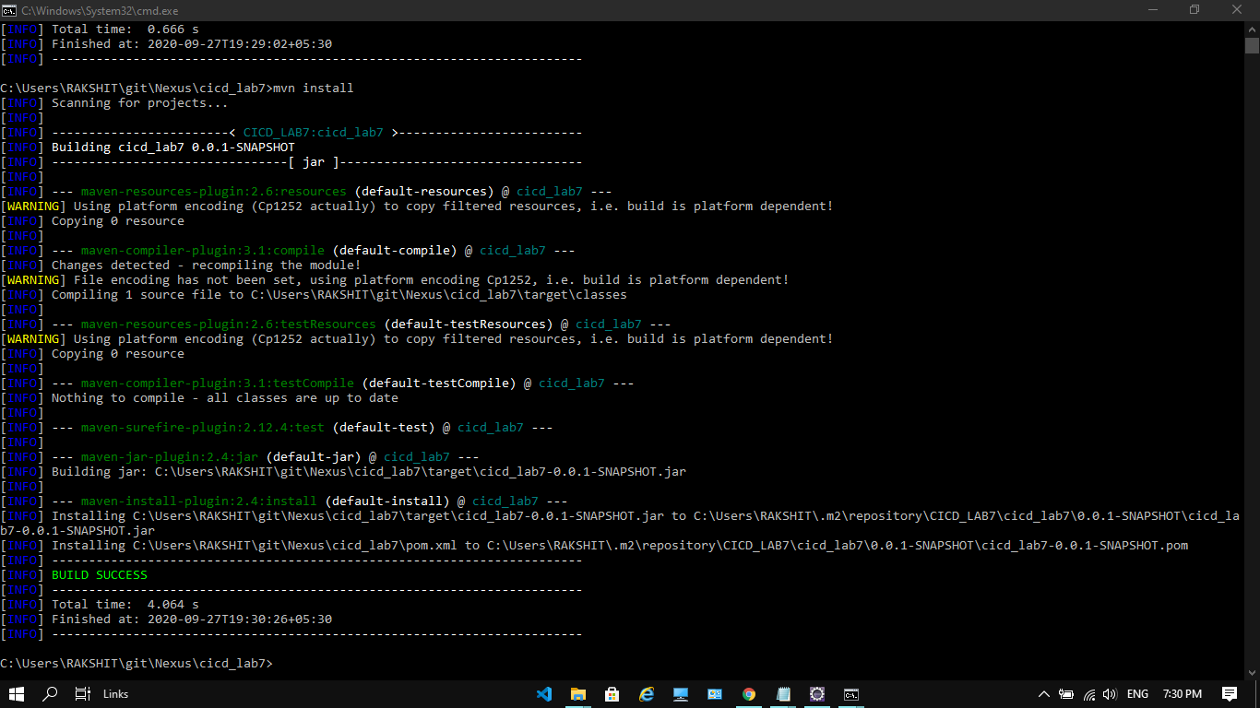

**Step-9:** Run “mvn deploy” to deploy the built jar on the Nexus server

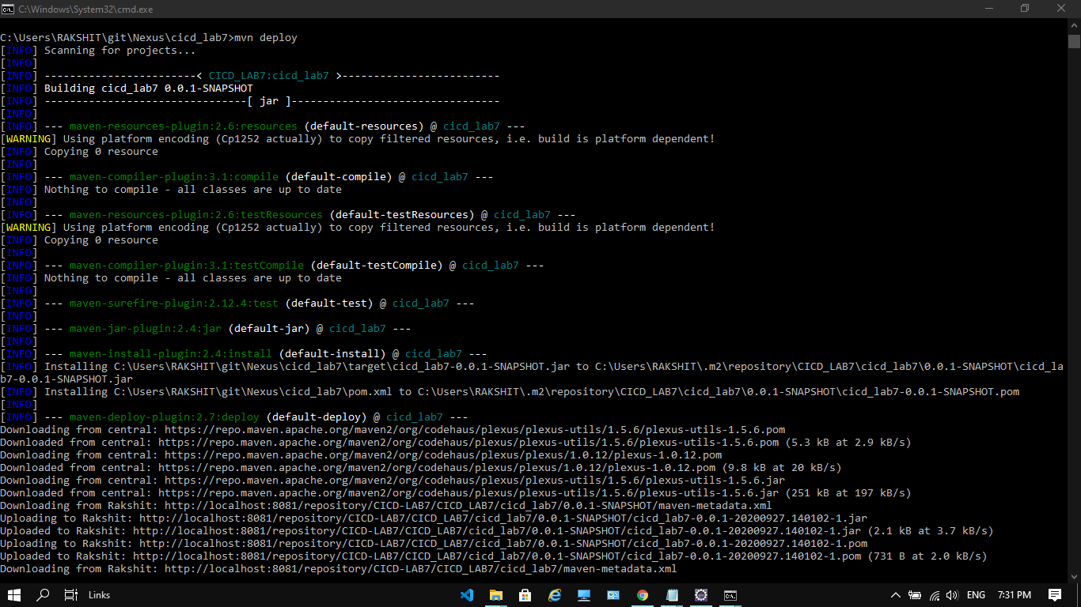

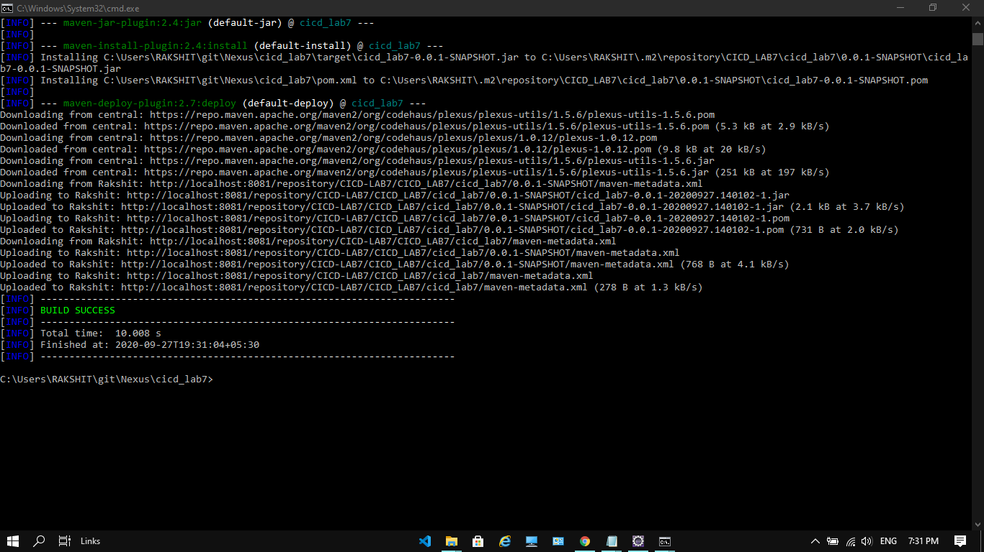

**Step-10:** Browse the Nexus repository now to see the deployed jar

